Dictionary Attack:
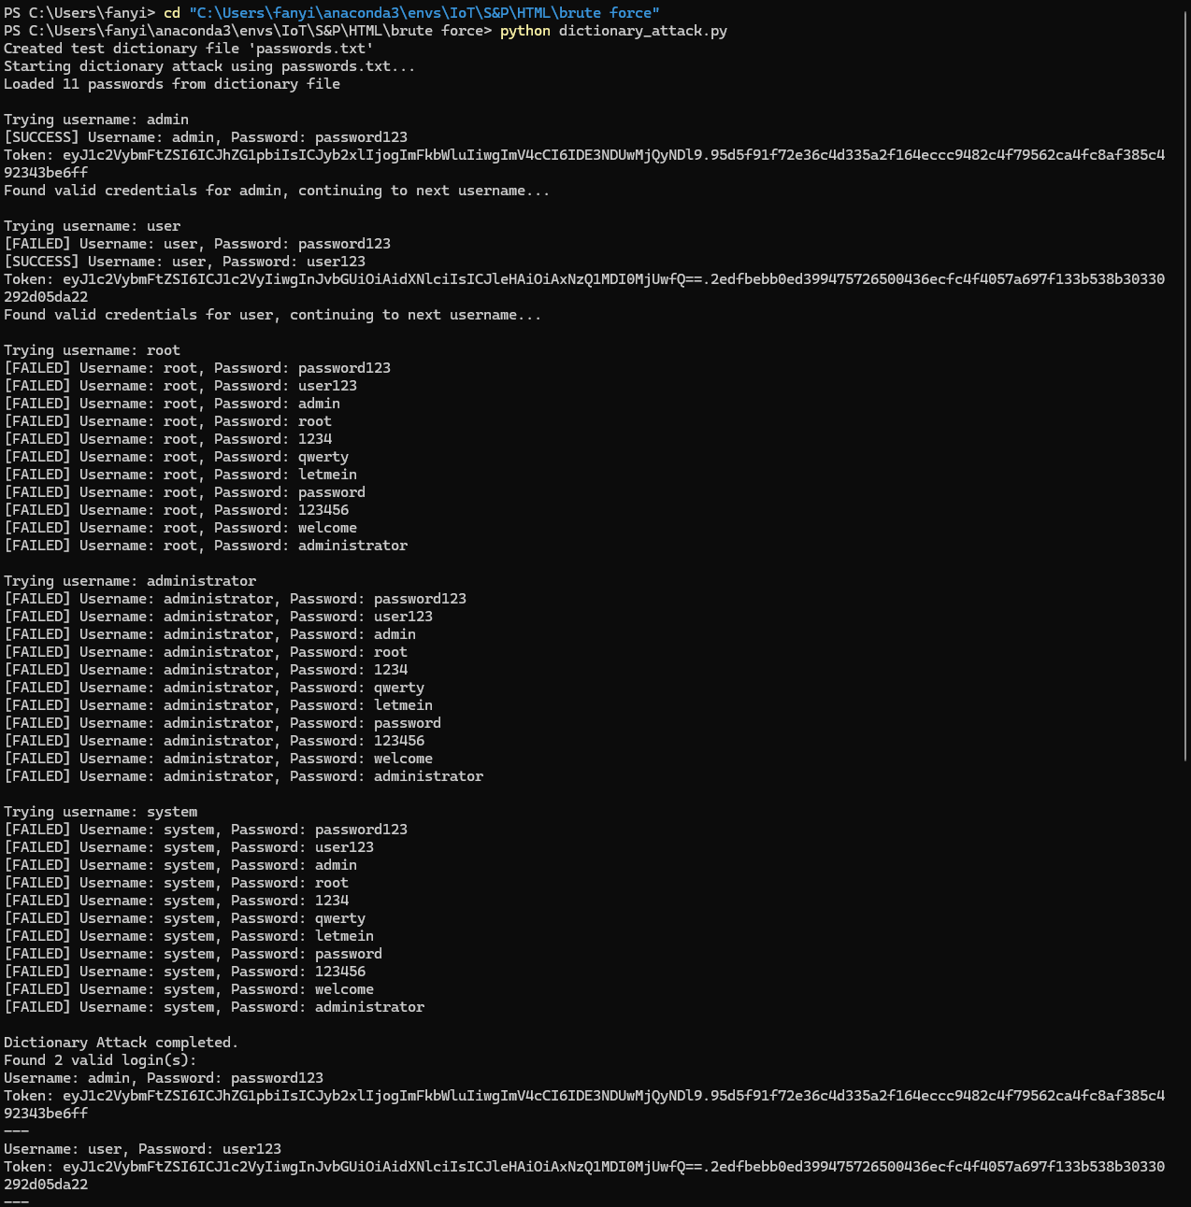
Threaded Attack:
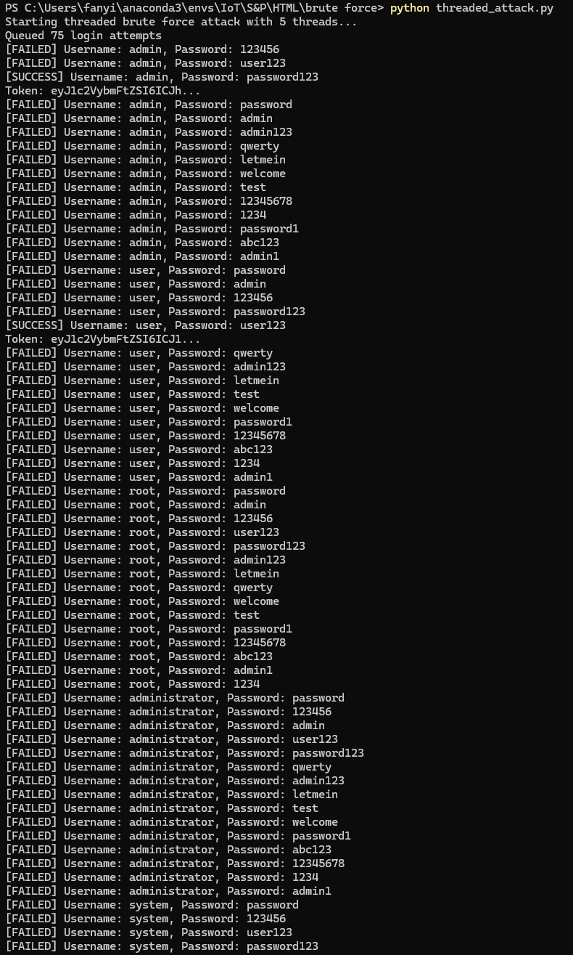
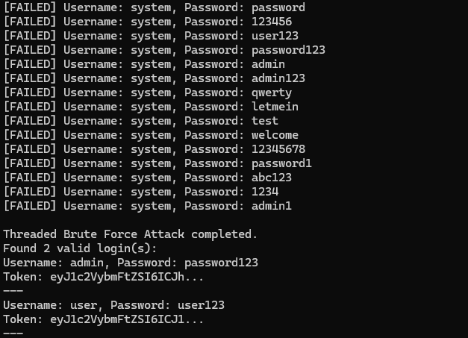

1. Dictionary Attack (dictionary_attack.py)
This script performs a dictionary-based brute force attack on a login API (/api/login). The attacker iterates over a list of common usernames and tries passwords from a dictionary file (or a built-in list if the file is missing). The attack is sequential, trying one username/password pair at a time.
- Purpose: To find valid login credentials by trying likely password guesses.
- Method:
  - Tries each username with all passwords from the dictionary.
  - Sends a POST request for each combination.
  - On a successful login (detected via the response JSON), it logs the credentials and token.

2. Threaded Brute Force Attack (threaded_attack.py)
This script enhances the dictionary attack by introducing concurrency using Python threads, speeding up the process.
It offers two modes:
- Queue-based threading: A work queue holds username/password pairs, and multiple threads fetch from it and try logins concurrently.
- Thread pool: Uses ThreadPoolExecutor to manage a pool of worker threads and map login tasks.
- Purpose: To perform brute force attacks more efficiently by parallelizing login attempts.
- Features:
  - Configurable thread count and delay.
  - Uses synchronization (Lock) to safely update shared state and print outputs.
  - Supports optional dictionary file input.

